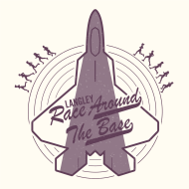

JBLE Langley AFB 10-Mile

Race Around the Base & 5K Fun Run

24 February 2024



**Open to the public.**

10-Miler: $40 registration fee **Registration closes 17 February 2024**

5K: $25 registration fee

Online registration only. **There is no race day registration**.

Race is limited to 250 participants total.

10-mile course is USATF certified (VA14072RT).

First 200 runners receive a race package:

10-Miler: Commemorative t-shirt, race bag, medal, water bottle and race towel.

5K: Commemorative t-shirt, and medal.

Awards: Overall 1st place for male and female runner. Top 3 male and female for each age group. Age groups are: 14 and under, 15-19, 20-29, 30-39, 40-49, 50-59, 60-69, 70 and over.

**\*\*\* If you need base access**, please email **Langleyratb@gmail.com** with:

1) Full name as it appears on driver’s license

2) Driver’s license number and state of issuance

3) Date of birth

No Rain Dates/No Refunds/No Race Day Registration.